1 | 2 | 3 | 4 | 5 | 6 | 7 |  | 1 | 2 | 3 | 4 | 5 | 6 | 7 | 8
Zones of Regulation | Democracy Week | Author Study: Alex T Smith  Claude in the City |  | Instruction writing  How to wash a woolly mammoth |  |  | Half term | Poetry  Lewis Carroll |  | Letter writing  Christmas letters |  | Newspaper reports  Unwrap the Joy (video) |  | Christmas Stories
English Long Term Plan
Year 3

1 | 2 | 3 | 4 | 5 | 6 |  | 1 | 2 | 3 | 4 | 5 | 6
Fiction  The Ice Palace |  |  |  | Trafford 500 words writing competition |  | Half term | Trafford 500 words writing competition |  | World Book Day 2023 |  | Poetry  Performance poetry

1 | 2 | 3 | 4 | 5 | 6 |  | 1 | 2 | 3 | 4 | 5 | 6
Playscript  May Queen | Playscript  May Queen  Script writing and assembly preparation |  | Diary entry  The Lighthouse (short film) |  |  | Half term | Traditional stories  Egyptian Cinderella |  | Non-Chronological Reports  Egypt: Now and Then |  | Poetry  Shape poems

Year 4

1 |  |  | 2 |  |  | 3 |  |  | 4 |  |  | 5 |  |  | 6 |  |  | 7 |  |  |  |  |  | 1 |  |  | 2 |  | 3 |  |  | 4 |  |  |  | 5 |  |  | 6 |  | 7 |  |  | 8
Fizzlebert Stump  Diary Writing |  |  |  |  |  |  |  |  |  |  |  |  |  |  |  |  |  |  |  |  | Half term |  |  | Greek Myths – Linked with History  Narrative & Description
 |  |  |  |  |  |  |  |  |  |  |  |  |  |  |  |  |  |  |  |  |  |  |  |  |  |  |  |  |  |  |  |  |  |  |  |  |  |  |  |  |  |  |  | Christmas
 |  | 1 |  |  | 2 |  |  | 3 |  |  | 4 |  |  | 5 |  | 6 |  |  |  |  |  |  | 1 |  |  | 2 |  |  |  | 3 |  |  | 4 |  |  | 5 |  | 6 |  | 7
Christmas holiday |  | How to Train Your Dragon  Narrative, Recount, Alternative Ending |  |  |  |  |  |  |  |  |  |  |  |  |  |  |  |  | Half term |  |  |  | How to Train Your Dragon continued |  |  |  |  |  |  |  |  |  |  | The lost spellings  Poetry |  |  |  |  |  |  |  |  | Easter  Break
1 | 2 |  |  | 3 |  |  | 4 |  |  | 5 |  |  |  |  |  |  |  |  |  | 1 |  | 2 |  |  | 3 |  |  | 4 |  |  | 5 |  |  |  | 6
Paddington Bear  Persausive writing, Newspaper Report Writing |  |  |  |  |  |  |  |  |  |  |  |  | Whit holiday |  |  |  | Whit holiday |  |  | Non Chronological Report writing - Based on movie UP |  |  |  |  |  |  |  |  |  |  |  |  |  |  |  |  | Summer holiday

Year 5

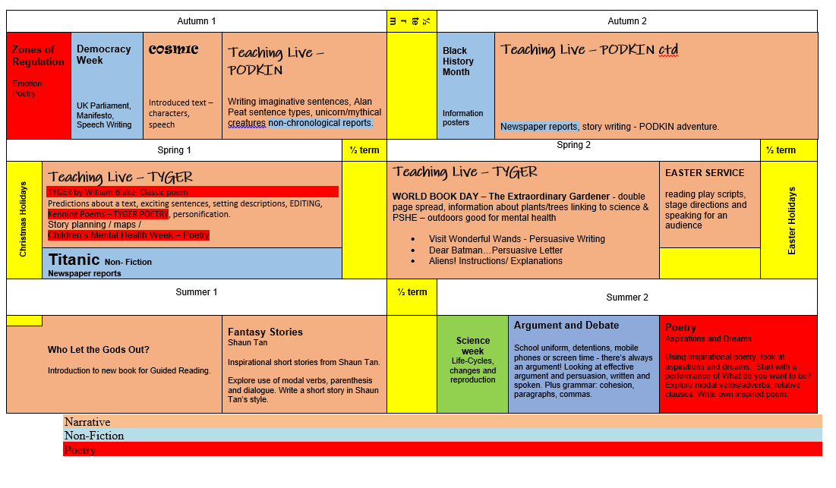
Year 6